**CP Club 365 Days Challenge**

**Programming language – C++**

**Problem Statement**

[https://practice.geeksforgeeks.org/problems/bfs-traversal-of-graph/1?page=1&difficulty[]=0&status[]=unsolved&curated[]=1&sortBy=submissions](https://practice.geeksforgeeks.org/problems/bfs-traversal-of-graph/1?page=1&difficulty%5b%5d=0&status%5b%5d=unsolved&curated%5b%5d=1&sortBy=submissions)

Git :- <https://github.com/Vedantbharad2603/CP_club_365_Days>

**Your Code**:

vector<int> bfsOfGraph(int V, vector<int> adj[]) {

            // Code here

            vector<int> toreturn;

            int temparr[V]={0};

            temparr[0]=1;

            queue<int> tempqueue;

            tempqueue.push(0);

            while(!tempqueue.empty()){

                int node=tempqueue.front();

                tempqueue.pop();

                toreturn.push_back(node);

                for(auto loop : adj[node]){

                    if(!temparr[loop]){

                        temparr[loop]=1;

                        tempqueue.push(loop);

                    }

                }

            }

            return toreturn;

        }

**Output (Screen Shot)**:

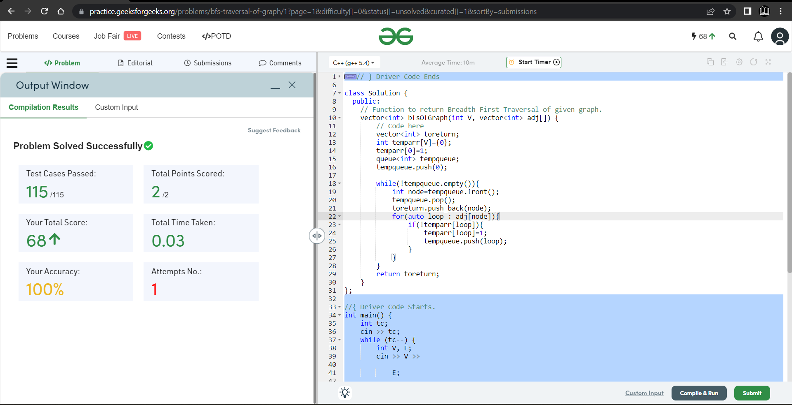

**Understanding about problem:**

* In this task I need to return vector in which there is Breadth First Traversal of given graph.

Note: If you can't understand the problem, feel free to contact us and we'll help you. Please don't copy and paste from anywhere.

ALL THE BEST

Team CP Club